Unit Testing
Unit testing involves the testing of each unit or an individual component of the software application. It is the first level of functional testing. The aim behind unit testing is to validate unit components with its performance.
A unit is a single testable part of a software system and tested during the development phase of the application software.
The purpose of unit testing is to test the correctness of isolated code. A unit component is an individual function or code of the application. White box testing approach used for unit testing and usually done by the developers.
Whenever the application is ready and given to the Test engineer, he/she will start checking every component of the module or module of the application independently or one by one, and this process is known as Unit testing or components testing.

Why Unit Testing?
In a testing level hierarchy, unit testing is the first level of testing done before integration and other remaining levels of the testing. It uses modules for the testing process which reduces the dependency of waiting for Unit testing frameworks, stubs, drivers and mock objects are used for assistance in unit testing.
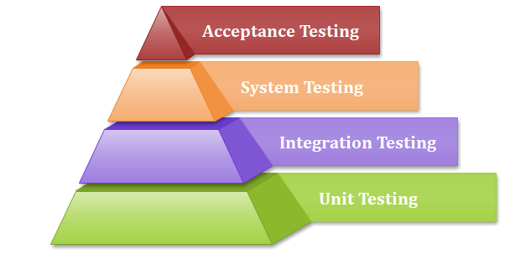
Generally, the software goes under four level of testing: Unit Testing, Integration Testing, System Testing, and Acceptance Testing but sometimes due to time consumption software testers does minimal unit testing but skipping of unit testing may lead to higher defects during Integration Testing, System Testing, and Acceptance Testing or even during Beta Testing which takes place after the completion of software application.
Some crucial reasons are listed below:
- Unit testing helps tester and developers to understand the base of code that makes them able to change defect causing code quickly.
- Unit testing helps in the documentation.
- Unit testing fixes defects very early in the development phase that's why there is a possibility to occur a smaller number of defects in upcoming testing levels.
- It helps with code reusability by migrating code and test cases.

Example of Unit testing
Let us see one sample example for a better understanding of the concept of unit testing:
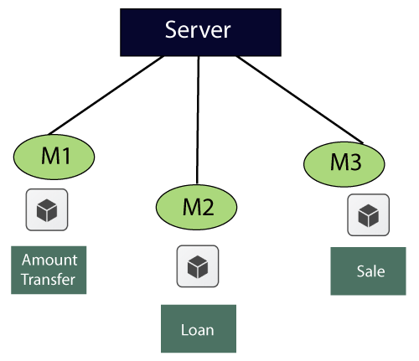
For the amount transfer, requirements are as follows:
1. | Amount transfer
1.1 | From account number (FAN)→ Text Box
1.1.1 | FAN→ accept only 4 digit
1.2 | To account no (TAN)→ Text Box
1.2.1 | TAN→ Accept only 4 digit
1.3 | Amount→ Text Box
1.3.1 | Amount → Accept maximum 4 digit
1.4 | Transfer→ Button
1.4.1 | Transfer → Enabled
1.5 | Cancel→ Button
1.5.1 | Cancel→ Enabled
Below are the application access details, which is given by the customer
- URL→ login Page
- Username/password/OK → home page
- To reach Amount transfer module follow the below
Loans → sales → Amount transfer
While performing unit testing, we should follow some rules, which are as follows:
- To start unit testing, at least we should have one module.
- Test for positive values
- Test for negative values
- No over testing
- No assumption required
When we feel that the maximum test coverage is achieved, we will stop the testing.
Now, we will start performing the unit testing on the different components such as
- From account number(FAN)
- To account number(TAN)
- Amount
- Transfer
- Cancel
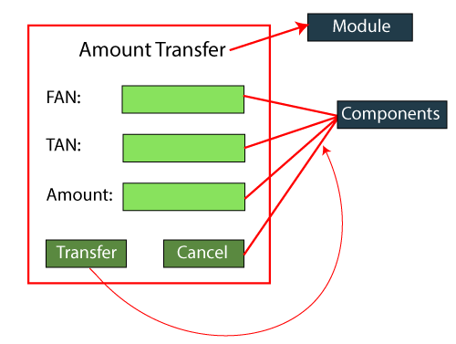
For the FAN components
Values | Description
1234 | accept
4311 | Error message→ account valid or not
blank | Error message→ enter some values
5 digit/ 3 digit | Error message→ accept only 4 digit
Alphanumeric | Error message → accept only digit
Blocked account no | Error message
Copy and paste the value | Error message→ type the value
Same as FAN and TAN | Error message
For the TAN component
- Provide the values just like we did in From account number (FAN) components
For Amount component
- Provide the values just like we did in FAN and TAN components.
For Transfer component
- Enter valid FAN value
- Enter valid TAN value
- Enter the correct value of Amount
- Click on the Transfer button→ amount transfer successfully( confirmation message)
For Cancel Component
- Enter the values of FAN, TAN, and amount.
- Click on the Cancel button → all data should be cleared.

Unit Testing Tools
We have various types of unit testing tools available in the market, which are as follows:
- NUnit
- JUnit
- PHPunit
- Parasoft Jtest
- EMMA
For more information about Unit testing tools, refers to the below link:
https://www.javatpoint.com/unit-testing-tools

Unit Testing Techniques:
Unit testing uses all white box testing techniques as it uses the code of software application:
- Data flow Testing
- Control Flow Testing
- Branch Coverage Testing
- Statement Coverage Testing
- Decision Coverage Testing

How to achieve the best result via Unit testing?
Unit testing can give best results without getting confused and increase complexity by following the steps listed below:
- Test cases must be independent because if there is any change or enhancement in requirement, the test cases will not be affected.
- Naming conventions for unit test cases must be clear and consistent.
- During unit testing, the identified bugs must be fixed before jump on next phase of the SDLC.
- Only one code should be tested at one time.
- Adopt test cases with the writing of the code, if not doing so, the number of execution paths will be increased.
- If there are changes in the code of any module, ensure the corresponding unit test is available or not for that module.

Advantages and disadvantages of unit testing
The pros and cons of unit testing are as follows:

Advantages
- Unit testing uses module approach due to that any part can be tested without waiting for completion of another parts testing.
- The developing team focuses on the provided functionality of the unit and how functionality should look in unit test suits to understand the unit API.
- Unit testing allows the developer to refactor code after a number of days and ensure the module still working without any defect.

Disadvantages
- It cannot identify integration or broad level error as it works on units of the code.
- In the unit testing, evaluation of all execution paths is not possible, so unit testing is not able to catch each and every error in a program.
- It is best suitable for conjunction with other testing activities.

Integration testing
Integration testing is the second level of the software testing process comes after unit testing. In this testing, units or individual components of the software are tested in a group. The focus of the integration testing level is to expose defects at the time of interaction between integrated components or units.
Unit testing uses modules for testing purpose, and these modules are combined and tested in integration testing. The Software is developed with a number of software modules that are coded by different coders or programmers. The goal of integration testing is to check the correctness of communication among all the modules.
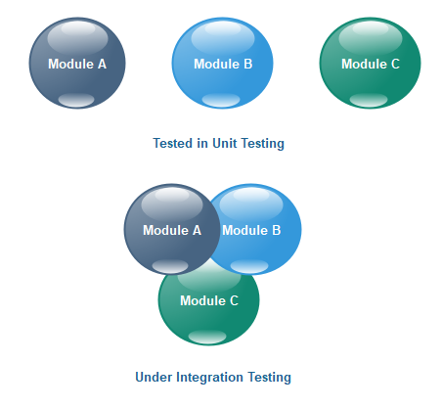
Once all the components or modules are working independently, then we need to check the data flow between the dependent modules is known as integration testing.
Let us see one sample example of a banking application, as we can see in the below image of amount transfer.
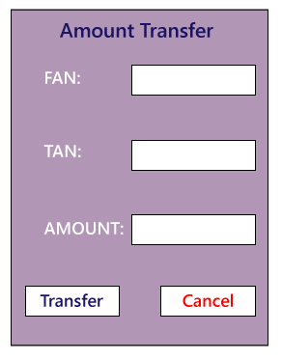
- First, we will login as a user P to amount transfer and send Rs200 amount, the confirmation message should be displayed on the screen as amount transfer successfully. Now logout as P and login as user Q and go to amount balance page and check for a balance in that account = Present balance + Received Balance. Therefore, the integration test is successful.
- Also, we check if the amount of balance has reduced by Rs200 in P user account.
- Click on the transaction, in P and Q, the message should be displayed regarding the data and time of the amount transfer.

Guidelines for Integration Testing
- We go for the integration testing only after the functional testing is completed on each module of the application.
- We always do integration testing by picking module by module so that a proper sequence is followed, and also we don't miss out on any integration scenarios.
- First, determine the test case strategy through which executable test cases can be prepared according to test data.
- Examine the structure and architecture of the application and identify the crucial modules to test them first and also identify all possible scenarios.
- Design test cases to verify each interface in detail.
- Choose input data for test case execution. Input data plays a significant role in testing.
- If we find any bugs then communicate the bug reports to developers and fix defects and retest.
- Perform positive and negative integration testing.
Here positive testing implies that if the total balance is Rs15, 000 and we are transferring Rs1500 and checking if the amount transfer works fine. If it does, then the test would be a pass.
And negative testing means, if the total balance is Rs15, 000 and we are transferring Rs20, 000 and check if amount transfer occurs or not, if it does not occur, the test is a pass. If it happens, then there is a bug in the code, and we will send it to the development team for fixing that bug.

Note: Any application in this world will do functional testing compulsory, whereas integration testing will be done only if the modules are dependent on each other. Each integration scenarios should compulsorily have source→ data→destination. Any scenarios can be called as integration scenario only if the data gets saved in the destination.
For example: In the Gmail application, the Source could be Compose, Data could be Email and the Destination could be the Inbox.

Example of integration testing
Let us assume that we have a Gmail application where we perform the integration testing.
First, we will do functional testing on the login page, which includes the various components such as username, password, submit, and cancel button. Then only we can perform integration testing.
The different integration scenarios are as follows:
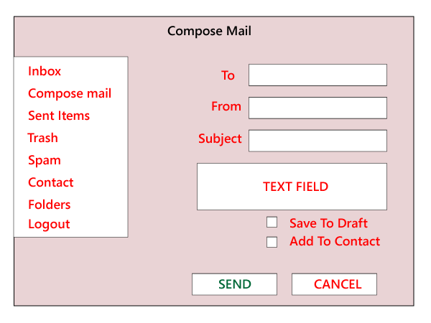
Scenarios1:
- First, we login as P users and click on the Compose mail and performing the functional testing for the specific components.
- Now we click on the Send and also check for Save Drafts.
- After that, we send a mail to Q and verify in the Send Items folder of P to check if the send mail is there.
- Now, we will log out as P and login as Q and move to the Inbox and verify that if the mail has reached.
Secanrios2: We also perform the integration testing on Spam folders. If the particular contact has been marked as spam, then any mail sent by that user should go to the spam folder and not in the inbox.

Note: We will perform functional testing for all features, such as to send items, inbox, and so on.
As we can see in the below image, we will perform the functional testing for all the text fields and every feature. Then we will perform integration testing for the related functions. We first test the add user, list of users, delete user, edit user, and then search user.
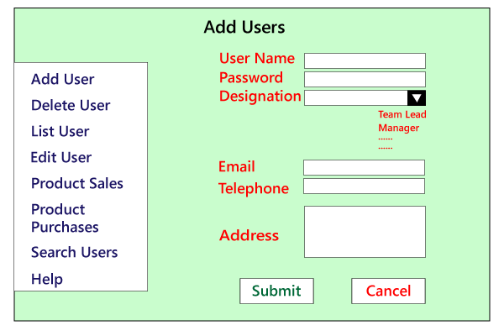
Note:
- There are some features, we might be performing only the functional testing, and there are some features where we are performing both functional and integration testing based on the feature's requirements.
- Prioritizing is essential, and we should perform it at all the phases, which means we will open the application and select which feature needs to be tested first. Then go to that feature and choose which component must be tested first. Go to those components and determine what values to be entered first.
And don't apply the same rule everywhere because testing logic varies from feature to feature.
- While performing testing, we should test one feature entirely and then only proceed to another function.
- Among the two features, we must be performing only positive integrating testing or both positive and negative integration testing, and this also depends on the features need.

Reason Behind Integration Testing
Although all modules of software application already tested in unit testing, errors still exist due to the following reasons:
- Each module is designed by individual software developer whose programming logic may differ from developers of other modules so; integration testing becomes essential to determine the working of software modules.
- To check the interaction of software modules with the database whether it is an erroneous or not.
- Requirements can be changed or enhanced at the time of module development. These new requirements may not be tested at the level of unit testing hence integration testing becomes mandatory.
- Incompatibility between modules of software could create errors.
- To test hardware's compatibility with software.
- If exception handling is inadequate between modules, it can create bugs.

Integration Testing Techniques
Any testing technique (Blackbox, Whitebox, and Greybox) can be used for Integration Testing; some are listed below:

Black Box Testing
- State Transition technique
- Decision Table Technique
- Boundary Value Analysis
- All-pairs Testing
- Cause and Effect Graph
- Equivalence Partitioning
- Error Guessing

White Box Testing
- Data flow testing
- Control Flow Testing
- Branch Coverage Testing
- Decision Coverage Testing

Types of Integration Testing
Integration testing can be classified into two parts:
- Incremental integration testing
- Non-incremental integration testing
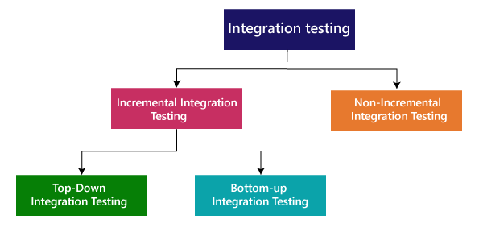

Incremental Approach
In the Incremental Approach, modules are added in ascending order one by one or according to need. The selected modules must be logically related. Generally, two or more than two modules are added and tested to determine the correctness of functions. The process continues until the successful testing of all the modules.
OR
In this type of testing, there is a strong relationship between the dependent modules. Suppose we take two or more modules and verify that the data flow between them is working fine. If it is, then add more modules and test again.
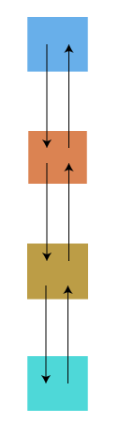
For example: Suppose we have a Flipkart application, we will perform incremental integration testing, and the flow of the application would like this:
Flipkart→ Login→ Home → Search→ Add cart→Payment → Logout
Incremental integration testing is carried out by further methods:
- Top-Down approach
- Bottom-Up approach

Top-Down Approach
The top-down testing strategy deals with the process in which higher level modules are tested with lower level modules until the successful completion of testing of all the modules. Major design flaws can be detected and fixed early because critical modules tested first. In this type of method, we will add the modules incrementally or one by one and check the data flow in the same order.
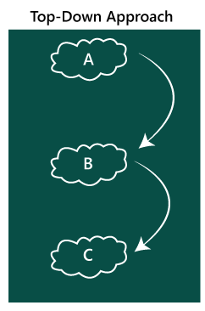
In the top-down approach, we will be ensuring that the module we are adding is the child of the previous one like Child C is a child of Child B and so on as we can see in the below image:
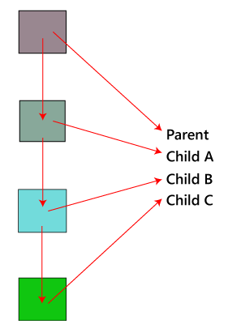
Advantages:
- Identification of defect is difficult.
- An early prototype is possible.
Disadvantages:
- Due to the high number of stubs, it gets quite complicated.
- Lower level modules are tested inadequately.
- Critical Modules are tested first so that fewer chances of defects.

Bottom-Up Method
The bottom to up testing strategy deals with the process in which lower level modules are tested with higher level modules until the successful completion of testing of all the modules. Top level critical modules are tested at last, so it may cause a defect. Or we can say that we will be adding the modules from bottom to the top and check the data flow in the same order.
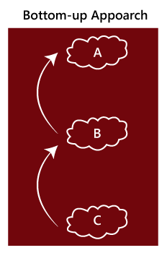
In the bottom-up method, we will ensure that the modules we are adding are the parent of the previous one as we can see in the below image:
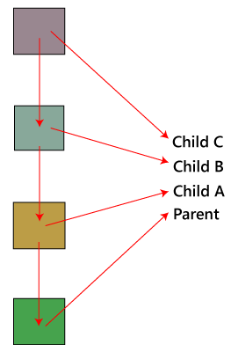
Advantages
- Identification of defect is easy.
- Do not need to wait for the development of all the modules as it saves time.
Disadvantages
- Critical modules are tested last due to which the defects can occur.
- There is no possibility of an early prototype.
In this, we have one addition approach which is known as hybrid testing.

Hybrid Testing Method
In this approach, both Top-Down and Bottom-Up approaches are combined for testing. In this process, top-level modules are tested with lower level modules and lower level modules tested with high-level modules simultaneously. There is less possibility of occurrence of defect because each module interface is tested.
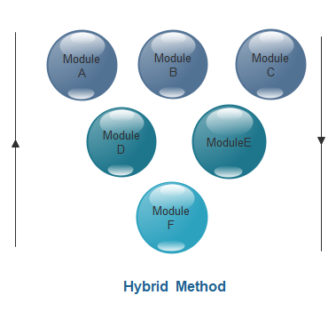
Advantages
- The hybrid method provides features of both Bottom Up and Top Down methods.
- It is most time reducing method.
- It provides complete testing of all modules.
Disadvantages
- This method needs a higher level of concentration as the process carried out in both directions simultaneously.
- Complicated method.

Non- incremental integration testing
We will go for this method, when the data flow is very complex and when it is difficult to find who is a parent and who is a child. And in such case, we will create the data in any module bang on all other existing modules and check if the data is present. Hence, it is also known as the Big bang method.
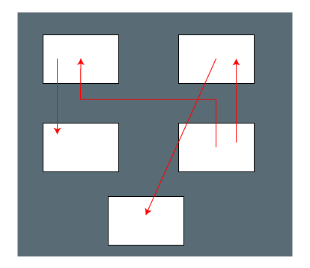

Big Bang Method
In this approach, testing is done via integration of all modules at once. It is convenient for small software systems, if used for large software systems identification of defects is difficult.
Since this testing can be done after completion of all modules due to that testing team has less time for execution of this process so that internally linked interfaces and high-risk critical modules can be missed easily.
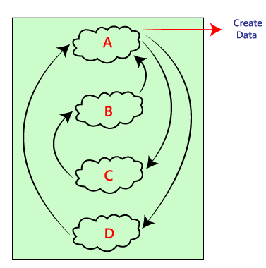
Advantages:
- It is convenient for small size software systems.
Disadvantages:
- Identification of defects is difficult because finding the error where it came from is a problem, and we don't know the source of the bug.
- Small modules missed easily.
- Time provided for testing is very less.
- We may miss to test some of the interfaces.
Let us see examples for our better understanding of the non-incremental integrating testing or big bang method:
Example1
In the below example, the development team develops the application and sends it to the CEO of the testing team. Then the CEO will log in to the application and generate the username and password and send a mail to the manager. After that, the CEO will tell them to start testing the application.
Then the manager manages the username and the password and produces a username and password and sends it to the test leads. And the test leads will send it to the test engineers for further testing purposes. This order from the CEO to the test engineer is top-down incremental integrating testing.
In the same way, when the test engineers are done with testing, they send a report to the test leads, who then submit a report to the manager, and the manager will send a report to the CEO. This process is known as Bottom-up incremental integration testing as we can see in the below image:

Note: The combination incremental integration testing (I.I.T) and non-incremental integration testing is known as sandwich testing.
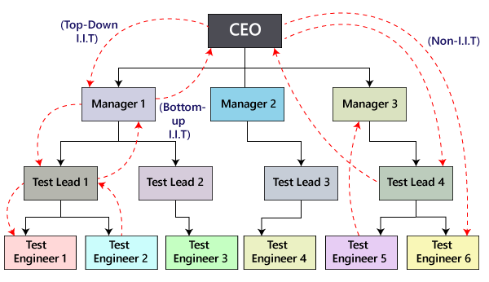
Example2
The below example demonstrates a home page of Gmail's Inbox, where we click on the Inbox link, and we are moved to the inbox page. Here we have to do non- incremental integration testing because there is no parent and child concept.
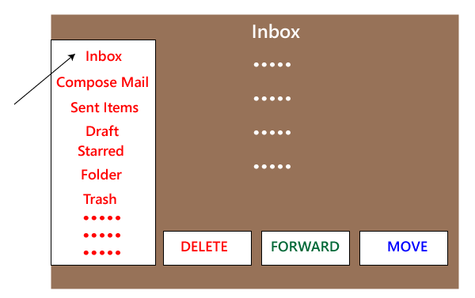
Note
Stub and driver
The stub is a dummy module that receives the data and creates lots of probable data, but it performs like a real module. When a data is sent from module P to Stub Q, it receives the data without confirming and validating it, and produce the estimated outcome for the given data.
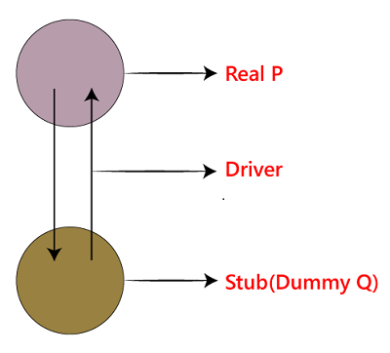
The function of a driver is used to verify the data from P and sends it to stub and also checks the expected data from the stub and sends it to P.
The driver is one that sets up the test environments and also takes care of the communication, evaluates results, and sends the reports. We never use the stub and driver in the testing process.
In White box testing, bottom-up integration testing is ideal because writing drivers is accessible. And in black box testing, no preference is given to any testing as it depends on the application.

Performance Testing
In this section, we will learn about performance testing, why we need it, types of performance testing, and the performance testing process.
Following are the topics, which we will understand in this section:

What is performance testing?
It is the most important part of non-functional testing.
Checking the behavior of an application by applying some load is known as performance testing.
Generally, this testing defines how quickly the server responds to the user's request.
While doing performance testing on the application, we will concentrate on the various factors like Response time, Load, and Stability of the application.
Response time: Response time is the time taken by the server to respond to the client's request.
Load: Here, Load means that when N-number of users using the application simultaneously or sending the request to the server at a time.
Stability: For the stability factor, we can say that, when N-number of users using the application simultaneously for a particular time.

When we use performance testing?
We will do performance testing once the software is stable and moved to the production, and it may be accessed by the multiple users concurrently, due to this reason, some performance issues may occur. To avoid these performance issues, the tester performs one round of performance testing.
Since it is non-functional testing which doesn't mean that we always use performance testing, we only go for performance testing when the application is functionally stable.

Note: Performance testing cannot be done manually since its costly and accurate result can't be maintained.

Types of Performance Testing
Following are the types of performance testing:
- Load testing
- Stress testing
- Scalability testing
- Stability testing
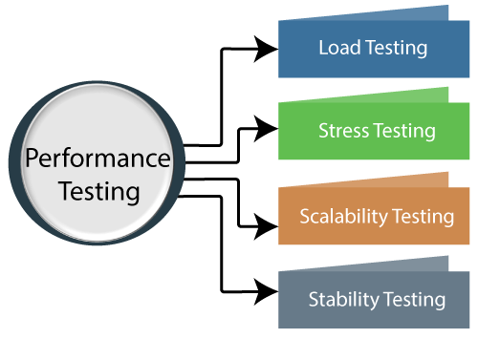
Let us discuss one by one to give you a complete understanding of Load, Stress, Scalability, and Stability performance testing.

Load testing
The load testing is used to check the performance of an application by applying some load which is either less than or equal to the desired load is known as load testing.
For example: In the below image , 1000 users are the desired load, which is given by the customer, and 3/second is the goal which we want to achieve while performing a load testing.
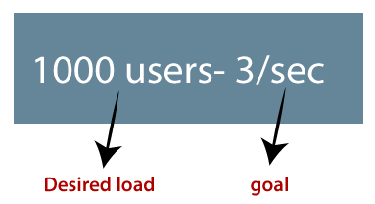

Stress Testing
The stress testing is testing, which checks the behavior of an application by applying load greater than the desired load.
For example: If we took the above example and increased the desired load 1000 to 1100 users, and the goal is 4/second. While performing the stress testing in this scenario, it will pass because the load is greater (100 up) than the actual desired load.
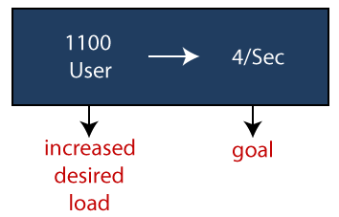

Scalability Testing
Checking the performance of an application by increasing or decreasing the load in particular scales (no of a user) is known as scalability testing. Upward scalability and downward scalability testing are called scalability testing.
Scalability testing is divided into two parts which are as follows:
- Upward scalability testing
- Downward scalability testing
Upward scalability testing
It is testing where we increase the number of users on a particular scale until we get a crash point. We will use upward scalability testing to find the maximum capacity of an application.
Downward scalability testing
The downward scalability testing is used when the load testing is not passed, then start decreasing the no. of users in a particular interval until the goal is achieved. So that it is easy to identify the bottleneck (bug).

Stability Testing
Checking the performance of an application by applying the load for a particular duration of time is known as Stability Testing.

Performance testing example
Let us take one example where we will test the behavior of an application where the desired load is either less than 1000 or equal to 1000 users.
In the below image, we can see that the 100 up users are increased continuously to check the maximum load, which is also called upward scalability testing.
- Scenario1: When we have the 1000 users as desired load, and the 2.7/sec is goal time, these scenarios will pass while performing the load test because in load testing, we will concentrate on the no. of users, and as per the requirement it is equal to 1000 user.
- Scenario2: In the next scenario, we will increase the desired load by 100 users, and goal time will go up to 3.5\sec. This scenario will pass if we perform stress testing because here, the actual load is greater than (1100) the desired load (1000).
- Scenario3: In this, if we increase the desired load three times as
1200 → 3.5\sec: [it is not less than or equal to the desired load that's why it will Fail]
1300 → 4\sec: [it is not less than or equal to the desired load. i.e., Fail]
1400 → Crashed
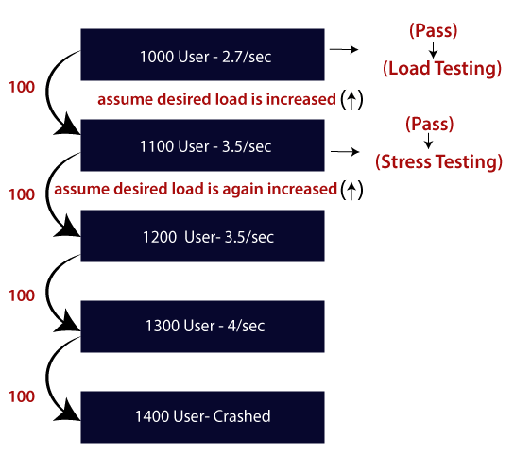

Note1: Volume and soak testing is a type of testing but not performance testing.
Volume testing
Volume testing is testing, which helps us to check the behavior of an application by inserting a massive volume of the load in terms of data is known as volume testing, and here, we will concentrate on the number of data rates than the number of users.

Note2:
Volume is a capacity while Load is a quantity, i.e., load testing means no. of users, and volume testing means amount of data.

Soak testing
In this type of testing, we will check the behavior of an application on the environment, which is unsupportive for a long duration of time is known as soak testing.
Generally, soak testing is a negative type of testing since we already know that the server or environment is not supportive.

Performance testing process
The performance testing cannot be done manually since:
- We need a lot of resources, and it became a costlier approach.
- And the accuracy cannot maintain when we track response time manually.
The Performance testing process will be completed in the following steps:
- Identify performance scenarios
- Plan and design performance test script
- Configure the test environment & distribute the load
- Execute test scripts
- Result
- Analysis result
- Identify the Bottleneck
- Re-run test
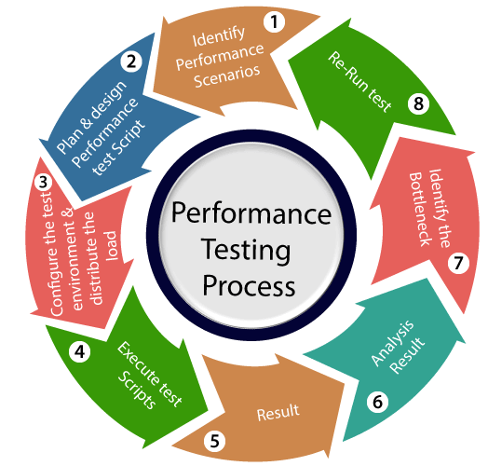
If we perform a positive flow of the performance testing process, it could follow the below process:

Identify performance scenarios
Firstly, we will identify the performance scenarios based on these below factors:
Most commonly scenarios: It means that we can find the performance scenarios based on the scenarios, which commonly used like in the Gmail application; we will perform login, inbox, send items, and compose a mail and logout.
Most critical scenarios: Critical scenarios mean regularly used and important for the business-like in Gmail application login, compose, inbox, and logout.
Huge data transaction: If we have huge data means that n-number of the users using the application at the same time.
Once we identify the performance scenarios, we will move to the next step.

Plan and design performance test script
In this step, we will install the tools in the Test Engineer Machine and access the test server and then we write some script according to the test scenarios and run the tool.
Once we are done with writing the script, we will go to the next step.

Configure the test environment & distribute the load
After writing the test scripts, we will arrange the testing environment before the execution. And also, manage the tools, other resources and distribute the load according to the "Usage Pattern" or mention the duration and stability.

Execute test scripts
Once we are done with distributing the load, we will execute, validate, and monitor the test scripts.

Result
After executing the test scripts, we will get the test result. And check that the result meeting the goal in the given response time or not, and the response time could be maximum, average, and minimum.
If the response is not meeting the required time response, then we will go for the negative flow where will perform the below steps:

Analysis result
First, we will analyze the test result whether it meets with the response time or not.

Identify the Bottleneck
After that, we will identify the bottleneck (bug or performance issue). And the bottleneck could occur because of these aspects like the problem in code, hardware issue (hard disk, RAM Processor), network issues, and the software issue (operating system). And after finding the bottleneck, we will perform tuning (fix or adjustment) to resolve this bottleneck.

Re-run test
Once we fix the bottlenecks, re-run the test scripts and checks the result whether it meets the required goal or not.

The problem occurs in performance testing
While performing performance testing on the application, some problems may occur, and these problems are also called the performance issue.
The performance issues are as follows:
- Response time issue
- Scalability issue
- Bottleneck
- Speed issue

Response time issue
The response time means how quickly the server respond to the client's request. If the user's request does not complete in the given response time, it might have possible that the user may be lost his/her interest in the particular software or application. That's why the application or software should have a perfect response time for responding user's request quickly.

Scalability issue
The scalability issues occur when the application cannot take the n-numbers of users and expected user requests at the same time. That's why we will do upward scalability testing (check the maximum capacity of the application) and downward scalability testing (when expected time is not matched with the actual time).

Bottleneck
The Bottleneck is the informal name of bug, which occurs when the application is limited by a single component and creates a bad impact on the system performance.
The main causes of bottlenecking are software issues (issue related to the operating system), hardware issues (issues related to the hard disk, RAM and the processor), and coding issue, etc.
Following are the most common performance bottlenecks:
- Memory utilization
- Disk usage
- CPU utilization
- Operating System limitations
- Network utilization

Speed issues
When we perform performance testing on the application, the application should be faster in speed to get the user's interest and attention because if the application's speed is slow, it may lose the user interest in the application.

Performance test tools
We have various types of performance testing tools available in the market, where some are commercial tools and open-source tool.
Commercial tools: LoadRunner[HP], WebLOAD, NeoLoad
Open-source tool: JMeter

LoadRunner
It is one of the most powerful tools of performance testing, which is used to support the performance testing for the extensive range of protocols, number of technologies, and application environments.
It quickly identifies the most common causes of performance issues. And also accurately predict the application scalability and capacity.

JMeter
The Apache JMeter software is an open- source tool, which is an entirely a Java application designed to load the functional test behavior and measure the performance.
Generally, it was designed for testing the Web Applications but now expanded to other test functions also.
Apache JMeter is used to test performance for both static and dynamic resources and dynamic web applications.
It can be used to reproduce the heavy load on a server, network or object, group of servers to test its strength or to analyze overall performance under different load types.

WebLOAD
WebLOAD testing tool used to test the load testing, performance testing, and stress test web applications.
The WebLOAD tool combines performance, scalability, and integrity as a single process for the verification of web and mobile applications.

NeoLoad
Neotys develop a testing tool which is called NeoLoad. The NeoLoad is used to test the performance test scenarios. With the help of NeoLoad, we can find the bottleneck areas in the web and the mobile app development process.
The NeoLoad testing tool is faster as compared to traditional tools.
Apart from them, some other tools are Electric load, web stress tool, LoadUI Pro, StresStimulus, LoadView, LoadNinja, and RedLine13, which helps to test the performance of the software or an application.

Load Testing vs. Stress Testing

Load testing
The load testing is the most important essential part of performance testing which is used to check the performance of an application by applying some load like less than or equal to the desired load is known as load testing. And the load is a quantity, which means it only focuses on the numbers of users.

Stress testing
The stress testing is testing, which checks the behavior of an application by applying load greater than the desired load. Since it is non-functional testing, so we use this testing when the application is functionally stable.

Difference between Load testing and Stress testing
Load testing | Stress testing
Load testing is used to find the performance of the application by testing the database, networks, and website servers. | Stress testing is used to find the stability and response time of the given system.
Load testing helps the tester to identify the bottleneck and also able to tell the cause of bottlenecks before deployment to the production server. | Stress testing helps the tester to check the system capacity when number of users increased suddenly before the system failure or crashed.
This type of testing reproduced the load on any application and software. | It is used to figure out the robustness and stability of the application.
Load testing is used to test web-based and client-server types of application. | Stress testing tests suddenly increased traffic of the application.
WebLOAD, LoadView, LoadRunner, SmartMeter.io, and LoadUI NG Pro are some of the load testing tools which help us to perform load testing on the applications. | LoadRunner, JMeter, NeoLoad are some of the stress testing tools which help us to perform stress testing on the applications.
After doing the load testing on the application, the cost of failure may reduce, and the satisfaction of the customer is increased. | After doing Stress testing on the application, if the system got to fail, it will recover quickly by finding the breaking point early and also see where the system got crashed.
For example: if we have one scenario where the load is 100 users using the application at a 2.5\sec of goal time.  And, the desired load is 100 user.  This scenario got passed because the desired load is equal to the load, which satisfies the load testing condition. | For example: if we took the same scenario where the actual load of 100 users which are using the application at a 2.5\sec of goal time.  When the desired load got increased by 200 users, and it will become 300. So now, 300 users using the application at 2.5\sec of goal time.  It will pass because the desired load is greater than the load according to the stress testing condition.

Security Testing

What is security testing?
Security testing is an integral part of software testing, which is used to discover the weaknesses, risks, or threats in the software application and also help us to stop the nasty attack from the outsiders and make sure the security of our software applications.
The primary objective of security testing is to find all the potential ambiguities and vulnerabilities of the application so that the software does not stop working. If we perform security testing, then it helps us to identify all the possible security threats and also help the programmer to fix those errors.
It is a testing procedure, which is used to define that the data will be safe and also continue the working process of the software.

Principle of Security testing
Here, we will discuss the following aspects of security testing:
- Availability
- Integrity
- Authorization
- Confidentiality
- Authentication
- Non-repudiation
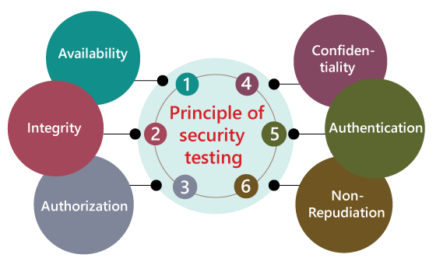

Availability
In this, the data must be retained by an official person, and they also guarantee that the data and statement services will be ready to use whenever we need it.

Integrity
In this, we will secure those data which have been changed by the unofficial person. The primary objective of integrity is to permit the receiver to control the data that is given by the system.
The integrity systems regularly use some of the similar fundamental approaches as confidentiality structures. Still, they generally include the data for the communication to create the source of an algorithmic check rather than encrypting all of the communication. And also verify that correct data is conveyed from one application to another.

Authorization
It is the process of defining that a client is permitted to perform an action and also receive the services. The example of authorization is Access control.


Confidentiality
It is a security process that protracts the leak of the data from the outsider's because it is the only way where we can make sure the security of our data.

Authentication
The authentication process comprises confirming the individuality of a person, tracing the source of a product that is necessary to allow access to the private information or the system.


Non- repudiation
It is used as a reference to the digital security, and it a way of assurance that the sender of a message cannot disagree with having sent the message and that the recipient cannot repudiate having received the message.
The non-repudiation is used to ensure that a conveyed message has been sent and received by the person who claims to have sent and received the message.

Key Areas in Security Testing
While performing the security testing on the web application, we need to concentrate on the following areas to test the application:
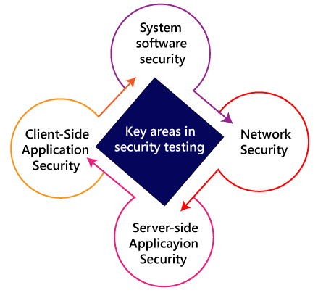

System software security
In this, we will evaluate the vulnerabilities of the application based on different software such as Operating system, Database system, etc.

Network security
In this, we will check the weakness of the network structure, such as policies and resources.

Server-side application security
We will do the server-side application security to ensure that the server encryption and its tools are sufficient to protect the software from any disturbance.

Client-side application security
In this, we will make sure that any intruders cannot operate on any browser or any tool which is used by customers.

Types of Security testing
As per Open Source Security Testing techniques, we have different types of security testing which as follows:
- Security Scanning
- Risk Assessment
- Vulnerability Scanning
- Penetration testing
- Security Auditing
- Ethical hacking
- Posture Assessment
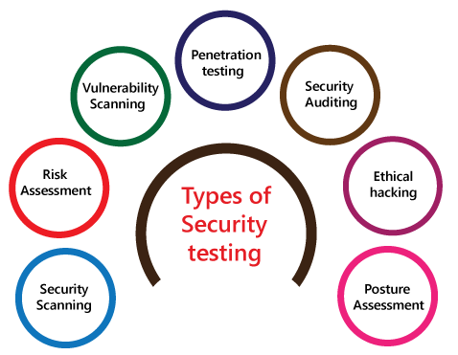

Security Scanning
Security scanning can be done for both automation testing and manual testing. This scanning will be used to find the vulnerability or unwanted file modification in a web-based application, websites, network, or the file system. After that, it will deliver the results which help us to decrease those threats. Security scanning is needed for those systems, which depends on the structure they use.

Risk Assessment
To moderate the risk of an application, we will go for risk assessment. In this, we will explore the security risk, which can be detected in the association. The risk can be further divided into three parts, and those are high, medium, and low. The primary purpose of the risk assessment process is to assess the vulnerabilities and control the significant threat.

Vulnerability Scanning
It is an application that is used to determine and generates a list of all the systems which contain the desktops, servers, laptops, virtual machines, printers, switches, and firewalls related to a network. The vulnerability scanning can be performed over the automated application and also identifies those software and systems which have acknowledged the security vulnerabilities.

Penetration testing
Penetration testing is a security implementation where a cyber-security professional tries to identify and exploit the weakness in the computer system. The primary objective of this testing is to simulate outbreaks and also finds the loophole in the system and similarly save from the intruders who can take the benefits.

Security Auditing
Security auditing is a structured method for evaluating the security measures of the organization. In this, we will do the inside review of the application and the control system for the security faults.

Ethical hacking
Ethical hacking is used to discover the weakness in the system and also helps the organization to fix those security loopholes before the nasty hacker exposes them. The ethical hacking will help us to increase the security position of the association because sometimes the ethical hackers use the same tricks, tools, and techniques that nasty hackers will use, but with the approval of the official person.
The objective of ethical hacking is to enhance security and to protect the systems from malicious users' attacks.

Posture Assessment
It is a combination of ethical hacking, risk assessments, and security scanning, which helps us to display the complete security posture of an organization.

How we perform security testing
The security testing is needed to be done in the initial stages of the software development life cycle because if we perform security testing after the software execution stage and the deployment stage of the SDLC, it will cost us more.
Now let us understand how we perform security testing parallel in each stage of the software development life cycle(SDLC).
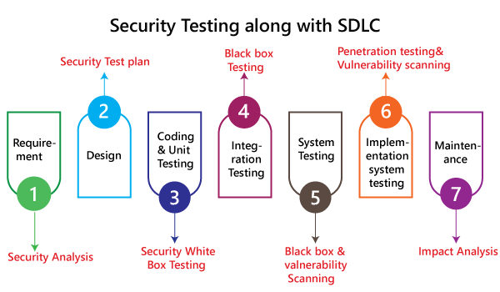
Step1
SDLC: Requirement stage
Security Procedures: In the requirement phase of SDLC, we will do the security analysis of the business needs and also verify that which cases are manipulative and waste.
Step2
SDLC: Design stage
Security Procedures: In the design phase of SDLC, we will do the security testing for risk exploration of the design and also embraces the security tests at the development of the test plan.
Step3
SDLC: Development or coding stage
Security Procedures: In the coding phase of SDLC, we will perform the white box testing along with static and dynamic testing.
Step4
SDLC: Testing (functional testing, integration testing, system testing) stage
Security Procedures: In the testing phase of SDLC, we will do one round of vulnerability scanning along with black-box testing.
Step 5
SDLC: Implementation stage
Security Procedures: In the implementation phase of SDLC, we will perform vulnerability scanning again and also perform one round of penetration testing.
Step 6
SDLC: Maintenance stage
Security Procedures: In the Maintenance phase of SDLC, we will do the impact analysis of impact areas.
And the test plan should contain the following:
- The test data should be linked to security testing.
- For security testing, we need the test tools.
- With the help of various security tools, we can analyze several test outputs.
- Write the test scenarios or test cases that rely on security purposes.

Example of security testing
Generally, the type of security testing includes the problematic steps based on overthinking, but sometimes the simple tests will help us to uncover the most significant security threats.
Let us see a sample example to understand how we do security testing on a web application:
- Firstly, log in to the web application.
- And then log out of the web application.
- Then click the BACK button of the browser to verify that it was asking us to log in again, or we are already logged-in the application.

Why security testing is essential for web applications
At present, web applications are growing day by day, and most of the web application is at risk. Here we are going to discuss some common weaknesses of the web application.
- Client-side attacks
- Authentication
- Authorization
- Command execution
- Logical attacks
- Information disclosure

Client-side attacks
The client-side attack means that some illegitimate implementation of the external code occurs in the web application. And the data spoofing actions have occupied the place where the user believes that the particular data acting on the web application is valid, and it does not come from an external source.

Note: Here, Spoofing is a trick to create duplicate websites or emails.

Authentication
In this, the authentication will cover the outbreaks which aim to the web application methods of authenticating the user identity where the user account individualities will be stolen. The incomplete authentication will allow the attacker to access the functionality or sensitive data without performing the correct authentication.
For example, the brute force attack, the primary purpose of brute force attack, is to gain access to a web application. Here, the invaders will attempt n-numbers of usernames and password repeatedly until it gets in because this is the most precise way to block brute-force attacks.
After all, once they try all defined number of an incorrect password, the account will be locked automatically.

Authorization
The authorization comes in the picture whenever some intruders are trying to retrieve the sensitive information from the web application illegally.
For example, a perfect example of authorization is directory scanning. Here the directory scanning is the kind of outbreaks that deeds the defects into the webserver to achieve the illegal access to the folders and files which are not mentioned in the pubic area.
And once the invaders succeed in getting access, they can download the delicate data and install the harmful software on the server.

Command execution
The command execution is used when malicious attackers will control the web application.

Logical attacks
The logical attacks are being used when the DoS (denial of service) outbreaks, avoid a web application from helping regular customer action and also restrict the application usage.

Information disclosure
The information disclosures are used to show the sensitive data to the invaders, which means that it will cover bouts that planned to obtain precise information about the web application. Here the information leakage happens when a web application discloses the delicate data, like the error message or developer comments that might help the attacker for misusing the system.
For example, the password is passing to the server, which means that the password should be encoded while being communicated over the network.
Note:
The web application needs more security regarding its access along with data security; that's why the web developer will make the application in such a way to protect the application from Brute Force Attacks, SQL Injections, Session Management, failure to Restrict URL Access and Cross-site scripting (XSS). And also, if the web application simplifies the remote access points, then it must be protected too.
Here, Session management: It is used to check whether the cookies can be re-used in another computer system during the login stage.
SQL injection: It is a code injection approach where the destructive SQL Statements are implanted into some queries, and it is implemented by the server.
Cross-site scripting (XSS): This is the technique through which the user introduces client-side script or the HTML in the user-interface of a web application and those additions are visible to other users.

Myths and Facts of Security testing
Here, we will discuss the Myths and facts of security testing:
Myths | Facts
There is no profit on an asset in security testing. | Security Testing can highlight the parts of enhancement, which help us to increase productivity and decrease interruption and also allow the maximum output.
Nowadays, the Internet is not safe, and we will be buying the hardware or software to save the business and protect the system. | Here, the fact is rather purchasing any software or hardware, the company first understands security and then follows the security process.
If we have a small business and we do not require a security procedure. | In that case, the fact is every organization needs a security procedure.
The only technique to secure is to disconnect it. | The one and the most excellent way to protect an association is to identify the Perfect Security. Here Perfect security can be accomplished by performing the implementation, compared with business, permitted, and manufacturing validations.

Security testing tools
We have various security testing tools available in the market, which are as follows:
- SonarQube
- ZAP
- Netsparker
- Arachni
- IronWASP
For more information about these tools, refer to the below link:
https://www.javatpoint.com/security-testing-tools

Conclusion
For an application or the software, it is necessary to perform security testing to verify that the sensitive information is still private. In software testing, the security testing is essential because it helps us to save our necessary data ultimately. In this, the test engineer will act as an invader and test the system or detect the security defects.

The Differences Between Desktop Application testing, Client-Server Application Testing and Web Application Testing
In software testing, we have three different types of applications testing, such as:
- Desktop application Testing
- Client-server application Testing
- Web applications Testing
These software applications are being developed and created precisely to perform in different circumstances and areas.
All of the applications mentioned above relates to different environments where they can be tested individually and differently. In other words, we can say that the crucial aspect of this type of testing is the environment in which they are tested.
The user loses control over the environment entirely when the end-user continues from one testing type to another.
In this tutorial, we are going to understand the difference between these (Desktop, Client-Server, and Web Application Testing) types of applications.
But before we go through the difference between them, firstly, we will see the brief introduction of Desktop, Client-server, and Web applications testing.

What is Desktop Application Testing?
The first type of software application is the Desktop application. In a desktop application testing, the entire software is installed at the end-user machine, and only one user can access it at a time. The desktop application is further known as a Stand-alone application testing.
Basically, it is executed on personal computers, machines, and systems. In order to test the desktop application, we must know the operating system and database and how the user interacts with the application.
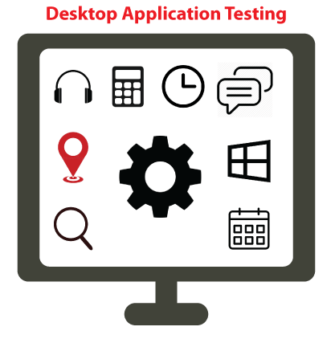
These types of applications concentrate only on the specific environment. The desktop application includes the analysis of the application entirely in elements such as Graphical User Interface (GUI), functionality, backend, database, and load.
And the end-user also needs to identify the different methods to test the memory leaks and unhandled exceptions.

Advantages of Desktop Application testing
Following are some of the significant advantage of desktop application testing:
- Security is there because data hacking is not possible in desktop application testing.
- These applications are faster to access.
- There is no need for any server while performing the desktop application.

Disadvantages of Desktop Application testing
Some of the vital drawbacks of desktop application are as follows:
- Only one user can access the stand-alone application at a time.
- The installation process is necessary in order to execute the desktop/stand-alone application.
- In this application testing, system resource is occupied.
- Data sharing is not possible while using desktop applications.
- The maintains is very high or difficult in desktop application testing because the application is installed in the user machine. If any issues have occurred, we need to contact the particular person to fix those issues.

What is Client-Server Application Testing?
Client-server application is another type of software application. These types of applications are single-user applications, which execute on two or more systems and knowledge of networking is needed while executing the client-server applications.
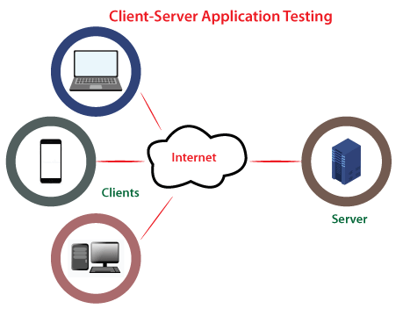
Basically, in the client-server application, we will test the application graphical user interface on both the systems such as server and client and also test the functionality, load, database, and communication between client and server.
The end-user needs to identify the load and performance issues and also work on the code space under the Client-server application. In client-server types of application testing, we can obtain the test cases and test scenarios with the help of requirements and understanding.
We can implement the following types of tests under the Client-server application:
- Manual testing
- Interoperability testing
- User interface testing
- Compatibility testing
- Functionality testing
- Configuration testing

Advantages of Client-Server Application testing
Following are some of the significant advantage of Client-server application:
- In the client-server application testing maintains is a bit easy as compared to the other applications.
- We can access these applications rapidly.
- The client-server application is secured in terms of data sharing.
- Various users can access the application simultaneously.
- We can easily share the data in client-server application testing.

Disadvantages of Client-server Application testing
Some of the vital drawbacks of Client-server application are as follows:
- If the server is down, no one can access the application, which is the major drawback of the client-server application testing.
- Installation is necessary in order to execute the client-server application testing.
- In this type of application testing, the system resource will be inhabited the space.

What is Web Application Testing?
Web applications are applications where we test the application on different browsers and diverse versions of the same browser and different operating systems. And this type of application can be executed on two or more machines.
In other words, we can say that the web-based application executes in a web browser instead of being installed on an end user's device. That means the entire software is installed at a server, and the end-user can access the particular application by using the URL.

These applications are used to analyze the browser similarity and operating system compatibility, attributes such as performance, usability, back-end, Graphical User Interface, accessibility.
These applications can by executed on any device that who has the internet connection such as desktop computers, tablets, and mobile phones.
Web applications are easily accessible, support several browsers and devices, platform-independent, which help us decrease the cost compared to the other types of software applications. Web-based applications are more complicated and require comprehensive testing.
To implement the web-based application, the test engineers need to know how the web application is communicating with the user. Understanding several technologies such as JavaScript, Php, debugging is also necessary while performing the web application testing.
We can implement the following types of tests under the web-based applications:
- Security testing
- User interface testing
- Browser compatibility testing
- Functionality testing
- Operating System compatibility testing
- Load testing
- Inter-operability testing
- Performance testing
- Storage and data volume testing
- Stress testing

Advantages of Web Application testing
Following are some of the significant advantage of web application:
- Like client-server applications, the web application can also be accessed by several users at a time.
- We can easily share the data in web-based application testing.
- These types of application testing can be accessed more rapidly.
- There is no need for any maintains and installation while implementing the web-based applications.
- In terms of data sharing, the web-based application is highly secured.

Disadvantages of Web Application testing
Following are some of the most common disadvantage of web application:
- No one can access the application if the server is down, which is the primary disadvantage of Web-based application testing.

Desktop Application VS Client-Server Application VS Web Application testing
Let us significant differences between desktop, client-server, and web application's testing into the below table:
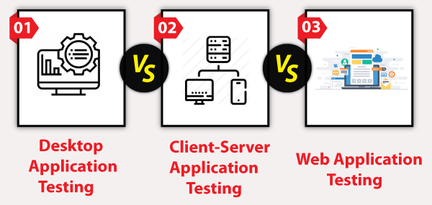
S.No. | Comparison Basis | Desktop Application Testing | Client-Server Application Testing | Web Application Testing
1. | Definition | The desktop application is those applications which are installed on one computer and only accessible by one person. | The Client-server application is those applications, which are installed on both client and server software in order to access the application. | Web-based applications are those applications, which are accessed through a browser. And these applications are URL-driven and executed on different web browsers.
2. | Number of users | The desktop application only accesses by a single user. | The client-server can be accessed by multiple users but limited number. | The web-based application can access by the n-numbers of users across the internet and browsers.
3. | Requirements | In order to implement the desktop application, we need at least one computer system or the workstation. | In order to execute the client-server application testing, we need at least one server for loading the application and one client machine or system. | The web application can be implemented by personal laptops remotely by using a web browser and internet connectivity.
4. | Executed on | The desktop application is executed on a single machine or workstation. | Generally, the Client-server application is executed on a 2-tier application. | Usually, web-based application testing is executed on the 3-tier application.
5. | Environments | The stand-alone or desktop application testing are platform-dependent; that's why the environment is a user machine. | Usually, in client-server application testing, environment is the intranet. | The environment is web browsers in the web-based application testing.
6. | Awareness | There is no client and server on the desktop or stand-alone applications. | In the Client-server application, we must be aware of the server location. | In the web application, we may or may not have any information about the server location.
7. | Type of driven applications | The stand-alone application is desktop-driven. | The client-server applications are menu-driven application testing. | Web application is usually URL-driven testing.
8. | Connectivity | In stand-alone application testing, there is no server or client. We are already aware that the Desktop applications don't need any internet connectivity because they are only hosted on the user machines. | There are two or more than two systems in client-server application testing where one is server, and another one is the client. And the application is loaded on the server, and installed on the client machines. | There are two or more systems in web application testing, where one is the server, and another one is the client. In this, the application is loaded on the server, and there is not an executable file. As we know, Web applications rely on internet connectivity to perform, and internet connectivity tests need to be executed to analyze the application functioning at different speeds.
9. | Accessibility | These applications may or may not needed authentic access in order to use it. | These application's user is already known before as they might have a username/password to open the application. | All users can approach these applications.
10. | Types of Tests Performed | In stand-alone applications, we test the following characteristics of the application or the software:  - Load  - Graphical User Interface (GUI) features  - Back-end (database) with the memory leaks issue. | In the Client-Server application, we will test the following qualities of applications:  - Functionality  - Load and performance aspects  - GUI (Graphical User Interface) on both sides.  - back-end. | In Web application testing, we will test the following features of the application:  - Browser and Operating System (OS) compatibility.  - User Interface Testing  - Broken Link Testing  - Data Volume testing  - Static page testing  - Load, Stress, Volume  - Cross-Browser testing.
11. | Examples | Some of the important examples of desktop/stand application are as follows:  - Adobe Photoshop Installing software w of a Calculator  - AutoCAD  - MS Office | Some of the important examples of Client-server application are as follows:  - Web Browsers  - FTP  - NET  - E-mail  - Gateway | Some of the significant examples of the web application is as follows:  - Facebook  - yahoo  - Gmail  - Twitter

Conclusion
After seeing all the significant differences between desktop, client-server, and web application testing, we can conclude that all of these applications are entirely different and have various benefits and drawbacks.
In simple words, we can say that if we are testing a stand-alone or desktop application, then the center should be environment-oriented because the stone-alone/desktop application is executed only in a precise environment.
To check the application's usability, backend, load, and other functionality, we should perform the Desktop applications.
On the other hand, in the client-server application testing, the user performance is predictable and manageable because Client-server applications do not need any browser as per the media in order to access the application.
Whereas performing the Web application testing itself is a crucial process to make sure that the web application under test can be easily retrieved by the actual users and working appropriately throughout all the operating systems and browsers.
To check the application's performance, features, accessibility, security, and usability, we should perform the Web applications.
Nearly every test engineer works with applications such as Desktop/stand-alone application, Client-Server application, and Web Application Testing.

What are the differences between Alpha Testing and Beta Testing?
Alpha testing is a type of acceptance testing, which is performed to identify all possible bugs/issues before releasing the product to the end-user. Alpha test is a preliminary software field test carried out by a team of users to find out the bugs that were not found previously by other tests. Alpha testing is to simulate a real user environment by carrying out tasks and operations that actual user might perform. Alpha testing implies a meeting with a software vendor and client to ensure that the developers appropriately meet the client's requirements in terms of the performance, functionality, and durability of the software.
Alpha testing needs lab environment, and usually, the testers are an internal employee of the organization. This testing is called alpha because it is done early on, near the end of the software development, but before beta testing.
Beta Testing is a type of acceptance testing; it is the final test before shipping a product to the customers. Beta testing of a product is implemented by "real users "of the software application in a "real environment." In this phase of testing, the software is released to a limited number of end-users of the product to obtain feedback on the product quality. It allows the real customers an opportunity to provide inputs into the design, functionality, and usability of the product. These inputs are essential for the success of the product. Beta testing reduces product failure risks and increases the quality of the product through customer validation. Direct feedback from customers is a significant advantage of beta testing. This testing helps to tests the software in a real environment. The experiences of the previous users are forwarded back to the developers who make final changes before releasing the software product.

Differences betwe ven the Alpha testing and Beta testing are:
Sr. No. | Alpha Testing | Beta Testing
1. | Alpha testing performed by a team of highly skilled testers who are usually the internal employee of the organization. | Beta testing performed by clients or end-users in a real-time environment, who is not an employee of the organization.
2. | Alpha testing performed at the developer's site; it always needs a testing environment or lab environment. | Beta testing doesn't need any lab environment or the testing environment; it is performed at a client's location or end-user of the product.
3. | Reliability or security testing not performed in-depth in alpha testing. | Reliability, security, and robustness checked during beta testing.
4. | Alpha testing involves both white box and black-box techniques. | Beta testing uses only black-box testing.
5. | Long execution cycles maybe require for alpha testing. | Only a few weeks are required for the execution of beta testing.
6. | Critical issues or fixes can be identified by developers immediately in alpha testing. | Most of the issues or feedback is collecting from the beta testing will be implemented for the future versions of the product.
7. | Alpha testing performed before the launch of the product into the market. | At the time of software product marketing.
8. | Alpha testing focuses on the product's quality before going to beta testing. | Beta testing concentrates on the quality of the product, but gathers users input on the product and ensures that the product is ready for real-time users.
9. | Alpha testing performed nearly the end of the software development. | Beta testing is a final test before shipping a product to the customers.
10. | Alpha testing is conducting in the presence of developers and the absence of end-users. | Beta testing reversed of alpha testing.

What is Regression Testing?
Regression testing is a black box testing techniques. It is used to authenticate a code change in the software does not impact the existing functionality of the product. Regression testing is making sure that the product works fine with new functionality, bug fixes, or any change in the existing feature.
Regression testing is a type of software testing. Test cases are re-executed to check the previous functionality of the application is working fine, and the new changes have not produced any bugs.
Regression testing can be performed on a new build when there is a significant change in the original functionality. It ensures that the code still works even when the changes are occurring. Regression means Re-test those parts of the application, which are unchanged.
Regression tests are also known as the Verification Method. Test cases are often automated. Test cases are required to execute many times and running the same test case again and again manually, is time-consuming and tedious too.

Example of Regression testing
Here we are going to take a case to define the regression testing efficiently:
Consider a product Y, in which one of the functionality is to trigger confirmation, acceptance, and dispatched emails. It also needs to be tested to ensure that the change in the code not affected them. Regressing testing does not depend on any programming language like Java, C++, C#, etc. This method is used to test the product for modifications or any updates done. It ensures that any change in a product does not affect the existing module of the product. Verify that the bugs fixed and the newly added features not created any problem in the previous working version of the Software.

When can we perform Regression Testing?
We do regression testing whenever the production code is modified.
We can perform regression testing in the following scenario, these are:
1. When new functionality added to the application.
Example:
A website has a login functionality which allows users to log in only with Email. Now providing a new feature to do login using Facebook.
2. When there is a Change Requirement.
Example:
Remember password removed from the login page which is applicable previously.
3. When the defect fixed
Example:
Assume login button is not working in a login page and a tester reports a bug stating that the login button is broken. Once the bug fixed by developers, tester tests it to make sure Login Button is working as per the expected result. Simultaneously, tester tests other functionality which is related to the login button.
4. When there is a performance issue fix
Example:
Loading of a home page takes 5 seconds, reducing the load time to 2 seconds.
5. When there is an environment change
Example:
When we update the database from MySql to Oracle.

How to perform Regression Testing?
The need for regression testing comes when software maintenance includes enhancements, error corrections, optimization, and deletion of existing features. These modifications may affect system functionality. Regression Testing becomes necessary in this case.
Regression testing can be performed using the following techniques:
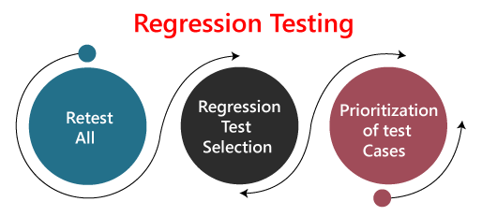
1. Re-test All:
Re-Test is one of the approaches to do regression testing. In this approach, all the test case suits should be re-executed. Here we can define re-test as when a test fails, and we determine the cause of the failure is a software fault. The fault is reported, we can expect a new version of the software in which defect fixed. In this case, we will need to execute the test again to confirm that the fault fixed. This is known as re-testing. Some will refer to this as confirmation testing.
The re-test is very expensive, as it requires enormous time and resources.
2. Regression test Selection:
- In this technique, a selected test-case suit will execute rather than an entire test-case suit.
- The selected test case suits divided in two cases
  - Reusable Test cases.
  - Obsolete Test cases.
- Reusable test cases can use in succeeding regression cycle.
- Obsolete test cases can't use in succeeding regression cycle.
3. Prioritization of test cases:
Prioritize the test case depending on business impact, critical and frequently functionality used. Selection of test cases will reduce the regression test suite.

What are the Regression Testing tools?
Regression Testing is a vital part of the QA process; while performing the regression we may face the below challenges:
- Time Consuming
Regression Testing consumes a lot of time to complete. Regression testing involves existing tests again, so testers are not excited to re-run the test.
- Complex
Regression Testing is complex as well when there is a need to update any product; lists of the test are also increasing.
- Communicating business rule
Regression Testing ensures the existing product features are still in working order. Communication about regression testing with a non-technical leader can be a difficult task. The executive wants to see the product move forward and making a considerable time investment in regression testing to ensure existing functionality working can be hard.
- Identify Impact Area
- Test Cases Increases Release by Release
- Less Resources
- No Accuracy
- Repetitive Task
- Monotonous Job

Regression Testing Process
The regression testing process can be performed across the builds and the releases.

Regression testing across the builds
Whenever the bug fixed, we retest the Bug, and if there is any dependent module, we go for a Regression Testing.
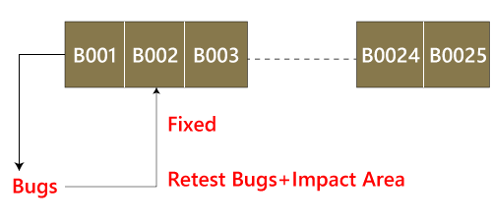
For example, How we perform the regression testing if we have different builds as Build 1, Build 2, and Build 3, which having different scenarios.
Build1
- Firstly the client will provide the business needs.
- Then the development team starts developing the features.
- After that, the testing team will start writing the test cases; for example, they write 900 test cases for the release#1 of the product.
- And then, they will start implementing the test cases.
- Once the product is released, the customer performs one round of acceptance testing.
- And in the end, the product is moved to the production server.
Build2
- Now, the customer asks for 3-4 extra (new) features to be added and also provides the requirements for the new features.
- The development team starts developing new features.
- After that, the testing team will start writing the test case for the new features, and they write about 150 new test cases. Therefore, the total number of the test case written is 1050 for both the releases.
- Now the testing team starts testing the new features using 150 new test cases.
- Once it is done, they will begin testing the old features with the help of 900 test cases to verify that adding the new feature has damaged the old features or not.
- Here, testing the old features is known as Regression Testing.
- Once all the features (New and Old) have been tested, the product is handed over to the customer, and then the customer will do the acceptance testing.
- Once the acceptance testing is done, the product is moved to the production server.
Build3
- After the second release, the customer wants to remove one of the features like Sales.
- Then he/she will delete all the test cases which are belonging to the sales module (about 120 test cases).
- And then, test the other feature for verifying that if all the other features are working fine after removing the sales module test cases, and this process is done under the regression testing.
Note:
- Testing the stable features to ensure that it is broken because of the changes. Here changes imply that the modification, addition, bug fixing, or the deletion.
- Re-execution of the same test cases in the different builds or releases is to ensure that changes (modification, addition, bug fixing, or the deletion) are not introducing bugs in stable features.

Regression Testing Across the Release
The regression testing process starts whenever there is a new Release for same project because the new feature may affect the old elements in the previous releases.
To understand the regression testing process, we will follow the below steps:
Step1
There is no regression testing in Release#1 because there is no modification happen in the Release#1 as the release is new itself.
Step2
The concept of Regression testing starts from Release#2 when the customer gives some new requirements.
Step3
After getting the new requirements (modifying features) first, they (the developers and test engineers) will understand the needs before going to the impact analysis.
Step4
After understanding the new requirements, we will perform one round of impact analysis to avoid the major risk, but here the question arises who will do the Impact analysis?
Step5
The impact analysis is done by the customer based on their business knowledge, the developer based on their coding knowledge, and most importantly, it is done by the test engineer because they have the product knowledge.

Note: If a single person does, he/she may not cover all the impact areas, so we include all persons so that we may cover a maximum impact area, and Impact Analysis should be done at the early stages of the releases.
Step6
Once we are done with the impact area, then the developer will prepare the impact area (document), and the customer will also prepare the impact area document so that we can achieve the maximum coverage of impact analysis.
Step7
After completing the impact analysis, the developer, the customer, and the test engineer will send the Reports# of the impact area documents to the Test Lead. And in the meantime, the test engineer and the developer are busy working on the new test case.
Step8
Once the Test lead gets the Reports#, he/she will consolidate the reports and stored in the test case requirement repository for the release#1.

Note: Test case Repository: Here, we will save all the test case of releases.
Step9
After that, the Test Lead will take the help of RTM and pick the necessary regression test case from the test case repository, and those files will be placed in the Regression Test Suite.
Note:
- The test lead will store the regression test case in the regression test suite for no further confusion.
- Regression test suite: Here, we will save all the impact area test documents.
- Regression Test Cases: These are the test cases of the old releases text document which need to be re-executed as we can see in the below image:
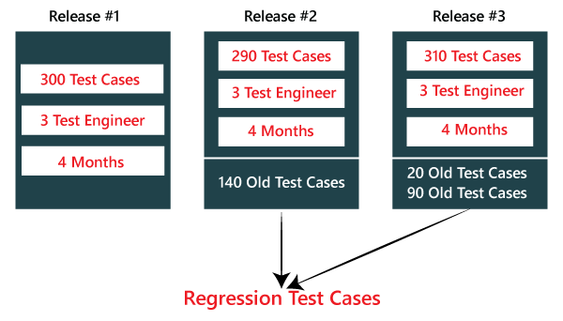
Step10
After that, when the test engineer has done working on the new test cases, the test lead will assign the regression test case to the test engineer.
Step11
When all the regression test cases and the new features are stable and pass, then check the impact area using the test case until it is durable for old features plus the new features, and then it will be handed over to the customer.
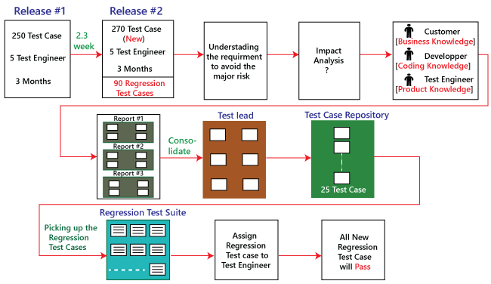

Types of Regression Testing
The different types of Regression Testing are as follows:
- Unit Regression Testing [URT]
- Regional Regression Testing[RRT]
- Full or Complete Regression Testing [FRT]
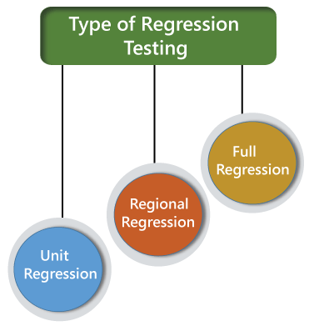

1) Unit Regression Testing [URT]
In this, we are going to test only the changed unit, not the impact area, because it may affect the components of the same module.
Example1
In the below application, and in the first build, the developer develops the Search button that accepts 1-15 characters. Then the test engineer tests the Search button with the help of the test case design technique.
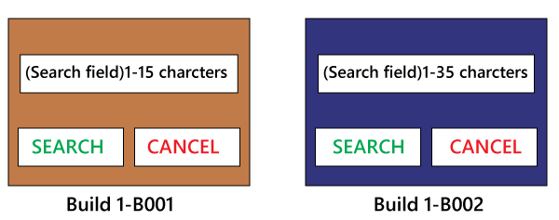
Now, the client does some modification in the requirement and also requests that the Search button can accept the 1-35 characters. The test engineer will test only the Search button to verify that it takes 1-35 characters and does not check any further feature of the first build.
Example2
Here, we have Build B001, and a defect is identified, and the report is delivered to the developer. The developer will fix the bug and sends along with some new features which are developed in the second Build B002. After that, the test engineer will test only after the defect is fixed.
- The test engineer will identify that clicking on the Submit button goes to the blank page.
- And it is a defect, and it is sent to the developer for fixing it.
- When the new build comes along with the bug fixes, the test engineer will test only the Submit button.
- And here, we are not going to check other features of the first build and move to test the new features and sent in the second build.
- We are sure that fixing the Submitbutton is not going to affect the other features, so we test only the fixed bug.
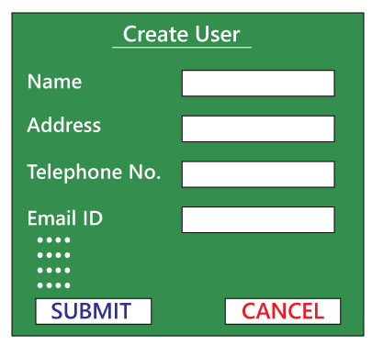
Therefore, we can say that by testing only the changed feature is called the Unit Regression Testing.

2) Regional Regression testing [RRT]
In this, we are going to test the modification along with the impact area or regions, are called the Regional Regression testing. Here, we are testing the impact area because if there are dependable modules, it will affect the other modules also.
For example:
In the below image as we can see that we have four different modules, such as Module A, Module B, Module C, and Module D, which are provided by the developers for the testing during the first build. Now, the test engineer will identify the bugs in Module D. The bug report is sent to the developers, and the development team fixes those defects and sends the second build.
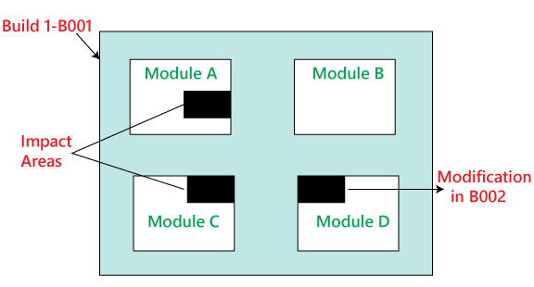
In the second build, the previous defects are fixed. Now the test engineer understands that the bug fixing in Module D has impacted some features in Module A and Module C. Hence, the test engineer first tests the Module D where the bug has been fixed and then checks the impact areas in Module A and Module C. Therefore, this testing is known as Regional regression testing.
While performing the regional regression testing, we may face the below problem:
Problem:
In the first build, the client sends some modification in requirement and also wants to add new features in the product. The needs are sent to both the teams, i.e., development and testing.
After getting the requirements, the development team starts doing the modification and also develops the new features based on the needs.
Now, the test lead sends mail to the clients and asks them that all are the impact areas that will be affected after the necessary modification have been done. Therefore, the customer will get an idea, which all features are needed to be tested again. And he/she will also send a mail to the development team to know which all areas in the application will be affected as a result of the changes and additions of new features.
And similarly, the customer sends a mail to the testing team for a list of impact areas. Hence, the test lead will collect the impact list from the client, development team, and the testing team as well.
This Impact list is sent to all the test engineers who look at the list and check if their features are modified and if yes, then they do regional regression testing. The impact areas and modified areas are all tested by the respective engineers. Every test engineer tests only their features that could have been affected as a result of the modification.
The problem with this above approach is that the test lead may not get the whole idea of the impact areas because the development team and the client may not have so much time to revert his/her mails.
Solution
To resolve the above problem, we will follow the below process:
When a new build comes along with the latest features and bug fixes, the testing team will arrange the meeting where they will talk about if their features are affecting because of the above modification. Therefore, they will do one round of Impact Analysis and generate the Impact List. In this particular list, the test engineer tries to enclose the maximum probable impact areas, which also decreases the chance of getting the defects.
When a new build comes, the testing team will follow the below procedure:
- They will do smoke testing to check the basic functionality of an application.
- Then they will test new features.
- After that, they will check the changed features.
- Once they are done with checking the changed features, the test engineer will re-test the bugs.
- And then they will check the impact area by performing the regional regression testing.

Disadvantage of using Unit and Regional Regression testing
Following are some of the drawbacks of using unit and Regional regression testing:
- We may miss some impact area.
- It is possible that we may identify the wrong impact area.

Note: We can say that the major work we do on the regional regression testing will lead us to get more number of defects. But, if we will perform the same dedication to work on the full regressing testing, we will get less number of defects. Therefore, we can determine here that enhancement in the testing effort will not help us to get more defects.

3) Full Regression testing [FRT]
During the second and the third release of the product, the client asks for adding 3-4 new features, and also some defects need to be fixed from the previous release. Then the testing team will do the Impact Analysis and identify that the above modification will lead us to test the entire product.
Therefore, we can say that testing the modified features and all the remaining (old) features is called the Full Regression testing.
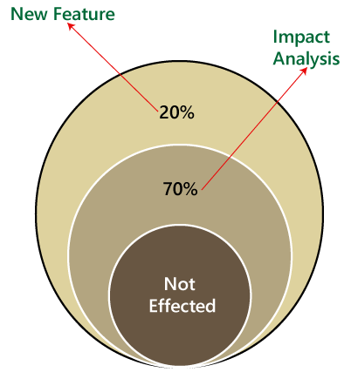

When we perform Full Regression testing?
We will perform the FRT when we have the following conditions:
- When the modification is happening in the source file of the product. For example, JVM is the root file of the JAVA application, and if any change is going to happen in JVM, then the entire JAVA program will be tested.
- When we have to perform n-number of changes.
Note:
The regional regression testing is the ideal approach of regression testing, but the issue is, we may miss lots of defects while performing the Regional Regression testing.
And here we are going to solve this issue with the help of the following approach:
- When the application is given for the testing, the test engineer will test the first 10-14 cycle, and will do the RRT.
- Then for the 15th cycle, we do FRT. And again, for the next 10-15 cycle, we do Regional regression testing, and for the 31th cycle, we do the full regression testing, and we will continue like this.
- But for the last ten cycle of the release, we will perform only complete regression testing.
Therefore, if we follow the above approach, we can get more defects.
The drawback of doing regression testing manually repeatedly:
- Productivity will decrease.
- It is a difficult job to do.
- There is no consistency in test execution.
- And the test execution time is also increased.
Hence, we will go for the automation to get over with these issues; when we have n-number of the regression test cycle, we will go for the automation regression testing process.

Automated Regression Testing Process
Generally we go for the automation whenever there are multiple releases or multiple regression cycle or there is the repetitive task.
The automation regression testing process can be done in the following steps:
Note1:
The process of testing the application by using some tools is known as automation testing.
Suppose if we take one sample example of a Login module, then how we can perform the regression testing.
Here, the Login can be done in two ways, which are as follows:
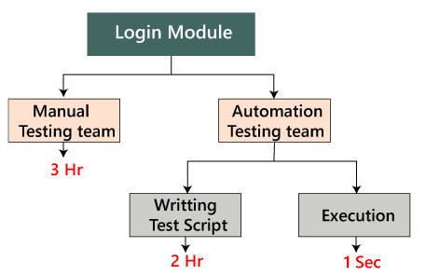
Manually: In this, we will perform regression only one and twice.
Automation: In this, we will do the automation multiple times as we have to write the test scripts and do the execution.

Note2: In real-time, if we have faced some issues such as:
Issues | Handle by
New features | Manual test engineer
Regressing testing features | Automation test engineer
Remaining ( 110 feature + Release#1) | Manual test engineer
Step1
When the new release starts, we don't go for the automation because there is no concept of regression testing and regression test case as we understood this in the above process.
Step2
When the new release and the enhancement starts, we have two teams, i.e., manual team and the automation team.
Step3
The manual team will go through the requirements and also identify the impact area and hand over the requirement test suite to the automation team.
Step4
Now, the manual team starts working on the new features, and the automation team will start developing the test script and also start automating the test case, which means that the regression test cases will be converted into the test script.
Step5
Before they (automation team) start automating the test case, they will also analyze which all cases can be automated or not.
Step6
Based on the analysis, they will start the automation i.e., converting every regression test cases into the test script.
Step7
During this process, they will take help of the Regression cases because they don't have product knowledge as well as the tool and the application.
Step8
Once the test script is ready, they will start the execution of these scripts on the new application [old feature]. Since, the test script is written with the help of the regression feature or the old feature.
Step9
Once the execution is completed, we get a different status like Pass/fail.
Step10
If the status is failed, which means it needs to be re-confirmed manually, and if the Bug exists, then it will report to the concerned developer. When the developer fixes that bug, the Bug needs to be re-tested along with the Impact area by the manual test engineer, and also the script needs to be re-executed by the automation test engineer.
Step11
This process goes on until all the new features, and the regression feature will be passed.
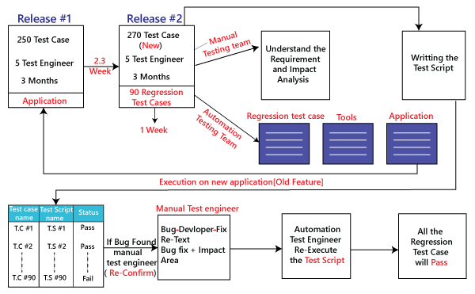

Benefits of doing regression testing by the automation testing:
- Accuracy always exists because the task is done by the tools and tools never get bored or tired.
- The test script can be re-used across multiple releases.
- Batch execution is possible using the automation i.e.; all the written test scripts can be executed parallel or simultaneously.
- Even though the number of regression test case increase release per release, and we don't have to increase the automation resource since some regression case are already automated from the previous release.
- It is a time-saving process because the execution is always faster than the manual method.

How to select test cases for regression testing?
It was found from industry inspection. The several defects reported by the customer were due to last-minute bug fixes. These creating side effects and hence selecting the Test Case for regression testing is an art, not an easy task.
Regression test can be done by:
- A test case which has frequent defects
- Functionalities which are more visible to users.
- Test cases verify the core features of the product.
- All integration test cases
- All complex test cases
- Boundary value test cases
- A sample of successful test cases
- Failure of test cases

Regression Testing Tools
If Software undergoes frequent changes, regression testing costs also increase. In those cases, manual execution of test cases increases test execution time as well as costs. In that case, automation testing is the best choice. The duration of automation depends on the number of test cases that remain reusable for successive regression cycles.
Following are the essential tools used for regression testing:
Selenium
Selenium is an open-source tool. This tool used for automated testing of a web application. For browser-based regression testing, selenium used. Selenium used for UI level regression test for web-based application.
Ranorex Studio
All in one regression test automation for desktop, web, and mobile apps with built-in Selenium Web Driver. Ranorex Studio includes full IDE plus tools for codeless automation.
Quick Test Professional (QTP)
QTP is an automated testing tool used for Regression and Functional Testing. It is a Data-Driven, keyword-based tool. It used VBScript language for automation. If we open the QTP tool, we see the three buttons which are Record, Play and Stop. These buttons help to record every click and action performed on the computer system. It records the actions and play it back.
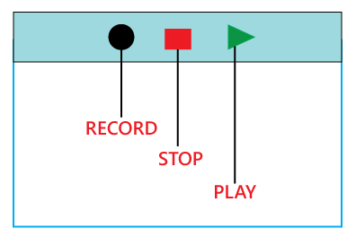
Rational Functional Tester (RTF)
Rational functional tester is a Java tool used to automate the test cases of software applications. RTF used for automating regression test cases, and it also integrates with the rational functional tester.
For more information about regression and automation testing tools refer to the below link:
https://www.javatpoint.com/automation-testing-tool

Regression Testing and Configuration Management
Configuration Management in the regression testing becomes imperative in Agile Environments, where a code is continuously modified. To ensure a valid regression test, we must follow the steps:
- Changes are not allowed in the code during the regression testing phase.
- A regression test case must be unaffected developer changes.
- The database used for regression testing must be isolated; changes are not allowed in the database.

Differences between Retesting and Regression Testing
Re-testing Testing means testing the functionality or bug again to ensure the code fixed. If not set, defects need not be re-opened. If fixed, the defect closed.
Re-testing is a type of testing which performed to check the test-cases that were unsuccessful in the final execution are successfully pass after the defects repaired.
Regression Testing means testing the software application when it undergoes a code change to ensure that new code has not affected other parts of the Software.
Regression testing is a type of testing executed to check whether a code has not changed the existing functionality of the application.
Differences between the Re-testing and Regression Testing are as follows:
Re-testing | Regression Testing
Re-testing is performed to ensure that the test cases that are failed in the final execution are passing after the defects fixed. | Regression Testing is done to confirm whether the code change has not affected the existing features.
Re-Testing works on defect fixes. | The purpose of regression testing is to ensure that the code changes adversely not affect the existing functionality.
Defect verification is the part of the Retesting. | Regression testing does not include defect verification
The priority of Retesting is higher than Regression Testing, so it is done before the Regression Testing. | Based on the project type and availability of resources, regression testing can be parallel to Retesting.
Re-Test is a planned Testing. | Regression testing is a generic Testing.
We cannot automate the test-cases for Retesting. | We can do automation for regression testing; manual testing could be expensive and time-consuming.
Re-testing is for failed test-cases. | Regression testing is for passed Test-cases.
Re-testing make sure that the original fault is corrected. | Regression testing checks for unexpected side effect.
Retesting executes defects with the same data and the same environment with different input with a new build. | Regression testing is when there is a modification or changes become mandatory in an existing project.
Re-testing cannot do before start testing. | Regression testing can obtain test cases from the functional specification, user tutorials and manuals, and defects reports in regards to the corrected problem.

Advantages of Regression Testing
Advantages of Regression Testing are:
- Regression Testing increases the product's quality.
- It ensures that any bug fix or changes do not impact the existing functionality of the product.
- Automation tools can be used for regression testing.
- It makes sure the issues fixed do not occur again.

Disadvantages of Regression Testing
There are several advantages of Regression Testing though there are disadvantages as well.
- Regression Testing should be done for small changes in the code because even a slight change in the code can create issues in the existing functionality.
- If in case automation is not used in the project for testing, it will time consuming and tedious task to execute the test again and again.

Conclusion
Regression Testing is one of the essential aspects as it helps to deliver a quality product which saves organizations time and money. It helps to provide a quality product by making sure that any change in the code does not affect the existing functionality.
For automating the regression test cases, there are several automation tools available. A tool should have the ability to update the test suite as the regression test suit needs to be updated frequently.

Graphical User Interface Testing (GUI) Testing

R
Rumor

• Read
• Discuss
• Courses

Graphical User Interface Testing (GUI) Testing is the process for ensuring proper functionality of the graphical user interface (GUI) for a specific application.GUI testing generally evaluates a design of elements such as layout, colors and also fonts, font sizes, labels, text boxes, text formatting, captions, buttons, lists, icons, links, and content. GUI testing processes may be either manual or automatic and are often performed by third-party companies, rather than developers or end users.
Feature of Graphical User Interface Testing (GUI):
There are some feature of GUI which are given below:
- It provides a customizable test report.
- It is run tests in parallel or distributed on a Selenium Grid with built-in Selenium Webdriver.
- It allows you to test the functionality from a user’s perspective.
- Sometimes the internal functions of the system work correctly but the user interface doesn’t then GUI testing is good to have in addition to the other types.
- It provides reliable object identification, even for web elements with dynamic IDs.
Types of Graphical User Interface Testing (GUI) Testing:
There are two types of GUI testing which are given below: Analog Recording, and Object based recording. These are explained as following below.
- Analog Recording:
This is always what people associate with GUI testing tools by analog recording, the testing tool basically captures specific mouse clicks, keyboard presses, and other user actions and then simply stores them in a file for playback. For example, it might record that a user left-clicked at position X = 500 pixels, Y = 400 pixels or typed the word “Search” in a box and pressed the [ENTER] key on their keyboard.
- Object based Recording:
In object based recording, the testing tool is able to connect programmatically to the application being tested and “see” each of the individual user interface components (a button, a text box, a hyperlink) as separate entities and is able to perform operations (click, enter text) and read the state (is it enabled, what is the label text, what is the current value) reliably regardless of where that object is on the screen.
Challenges with Graphical User Interface Testing (GUI) Testing:
There are some challenges that occur during Graphical user interface testing. These are given below.

